# Arrian on Alexander visits Siwa



In February 332, [Alexander](https://www.livius.org/articles/person/alexander-the-great/) visited the oasis Siwah in the Libyan desert, where he consulted the [oracle](https://www.livius.org/articles/concept/oracle/) of [Ammon](https://www.livius.org/articles/place/ammon-siwa/ammon-deity/). Nobody knows exactly what Alexander asked and what the god replied; but it is certain that Alexander started to think of himself as the son of Ammon. The Greek author [Arrian of Nicomedia](https://www.livius.org/sources/content/arrian/) describes the events in section 3.3-4 of his *Anabasis*, which was translated by M.M. Austin.

### Alexander visits Siwah

[3.3.1] At this point Alexander was seized with a longing to visit [Ammon](https://www.livius.org/articles/place/ammon-siwa/oasis/) in Libya; his intention was to consult the god, as the oracle of [Ammon](https://www.livius.org/articles/place/ammon-siwa/ammon-deity/) was reputed to be truthful and it was said that Perseus and [Heracles](https://www.livius.org/articles/mythology/heracles/) had consulted it [...].

[3.3.2] Alexander wanted to rival Perseus and Heracles, since he was descended from them both, and was also seeking to trace his birth back to Ammon, just as mythology traces that of Heracles and Perseus to [Zeus](https://www.livius.org/articles/religion/zeus/). He therefore set out for Ammon in this frame of mind, with the intention of finding out more exactly about his origins, or of claiming he had found out.

[3.3.3] The journey along the coast as far as Paraetonium was through deserted, though not waterless, country, for a distance of 280 kilometers according to [Aristobulus](https://www.livius.org/articles/person/aristobulus/). From there he turned inland, where the oracle of Ammon was to be found. The road is deserted, sandy for the most part and without water.

[3.3.4] But Alexander had the benefit of heavy rains, and he ascribed this to the divinity.

Another occurrence was attributed to divine intervention: whenever a south wind blows in that country, much of the road is covered with sand and the road marks disappear. One is in an ocean of sand, as it were, and it is impossible to tell one's direction, as there are no mountains or trees or solid hills to serve as signs and guide the travelers on their way, just as sailors go by the stars. Hence Alexander's army was advancing aimlessly and the guides could not tell the way.

[3.3.5] [Ptolemy](https://www.livius.org/articles/person/ptolemy-i-soter/) son of Lagus relates that two speaking snakes preceded the army and Alexander ordered the guides to follow them and trust in the divinity; the snakes then led the way to the oracle and back again.

[3.3.6] But [Aristobulus](https://www.livius.org/articles/person/alexander-the-great/alexander-3.3-arrians-sources/%20" \l "aristobulus) says (and most writers agree with him) that two crows flew in front of the army and served as guides to Alexander. I can assert that there must have been some divine intervention to help Alexander, because this is what seems probable. [...]

[3.4.1] The area where the sanctuary of Ammon is situated is circular in shape; it is completely deserted, covered with sand and waterless, but the site itself is small (it has a maximum breadth of 7 km). It is full of garden trees, olives and palms, and is the only part of the area to catch the dew [...].

[3.4.5] Alexander admired the site and consulted the god, and having received, as he put it, the answer which his heart desired he returned to Egypt by the same road, as Aristobulus says, though according to Ptolemy he followed a straight road to [Memphis](https://www.livius.org/articles/place/memphis/).

**Diodorus of Siculus on Alexander visiting Siwa**

*The Library of History of Diodorus Siculus* published in Vol. VIII of the Loeb Classical Library edition, 1963

Having settled the affairs of Egypt, Alexander went off to the Temple of Ammon, where he wished to consult the oracle of the god. When he had advanced half way along the coast, he was met by envoys from the people of Cyrenê,​43 who brought him a crown and magnificent gifts, among which were three hundred chargers and five handsome four-horse chariots. 3 He received the envoys cordially and made a treaty of friendship and alliance with them; then he continued with his travelling companions on to the temple. When he came to the desert and waterless part, he took on water and began to cross a country covered with an infinite expanse of sand. In four days their water had given out and they suffered from fearful thirst. 4 All fell into despair, when suddenly a great storm of rain burst from the heavens,​44 ending their shortage of water in a way which had not been foreseen, and which, therefore, seemed to those so unexpectedly rescued to have been due to the action of divine Providence. 5 They refilled their containers from a hollow in the ground, and again with a four p261 days' supply in case marched for four days and came out of the desert.​45 at one point, when their road could not be traced because of the sand dunes, the guide pointed out to the king that crows cawing on their right were calling their attention to the route which led to the temple.​46 6 Alexander took this for an omen, and thinking that the god was pleased by his visit pushed on with speed. First he came to the so‑called Bitter Lake, and then, proceeding another hundred furlongs, he passed by the Cities of Ammon.​47 Then, after a journey of one day, he approached the sanctuary.

50 1 The land where this temple lies is surrounded by a sandy desert and waterless waste, destitute of anything good for man. The oasis is fifty furlongs in length and breadth and is watered by many fine springs, so that it is covered with all sorts of trees, especially those valued for their fruit. It has a moderate climate like our spring and, surrounded as it is by very hot regions, alone furnishes to its people a contrasting mildness of temperature.​48 2 It is said that the sanctuary was built by Danaüs the Egyptian. The land, which is sacred to the god, is occupied on the south and west by Ethiopians, and on the north by p263 the Libyans, a nomadic people, and the so‑called Nasamonians who reach on into the interior.49

3 All the people of Ammon dwell in villages. In the midst of their country there is a fortress secured by triple walls.​50 The innermost circuit encloses the palace of the ancient rulers; the next, the women's court, the dwellings of the children, women, and relatives, and the guardrooms of the scouts, as well as the sanctuary of the god and the sacred spring, from the waters of which offerings addressed to the god take on holiness; the outer circuit surrounds the barracks of the king's guards and the guardrooms of those who protect the person of the ruler.51

4 Outside of the fortress at no great distance there is another temple of Ammon shaded by many large trees, and near this is the spring which is called the Spring of the Sun from its behaviour.​52 Its waters change in temperature oddly in accordance with the times of day. 5 At sunrise it sends forth a warm stream, but as the day advances it grows cooler proportionally with the passage of the hours, until under the noonday heat it reaches the extreme degree of cold. Then again in the same proportion it grows warmer toward evening and as the night advances it continues to heat up until midnight when again the trend is reversed, p265 and at daybreak once more the waters have returned to their original temperature.

6 The image of the god is encrusted with emeralds and other precious stones, and answers those who consult the oracle in a quite peculiar fashion. It is carried about upon a golden boat by eighty priests, and these, with the god on their shoulders, go without their own volition wherever the god directs their path. 7 A multitude of girls and women follows them singing hymns as they go and praising the god in a traditional hymn.53

51 1 When Alexander was conducted by the priests into the temple and had regarded the god for a while, the one who held the position of prophet, an elderly man, came to him and said, "Rejoice, son;​54 take this form of address as from the god also." 2 He replied, "I accept, father; for the future I shall be called thy son. But tell me if thou givest me the rule of the whole earth." The priest now entered the sacred enclosure and as the bearers now lifted the god and were moved according to certain prescribed sounds of the voice,​55 the prophet cried that of a certainty the god had granted him his request, and Alexander spoke again: "The last, O spirit, of my questions now answer; have I punished all those who were the p267 murderers of my father or have some escaped me?" 3 The prophet shouted: "Silence! There is no mortal who can plot against the one who begot him. All the murderers of Philip, however, have been punished. The proof of his divine birth will reside in the greatness of his deeds; as formerly he has been undefeated, so now he will be unconquerable for all time." 4 Alexander was delighted with these responses. He honoured the god with rich gifts and returned to Egypt.56

**Plutarch on Alexander visiting Siwa**

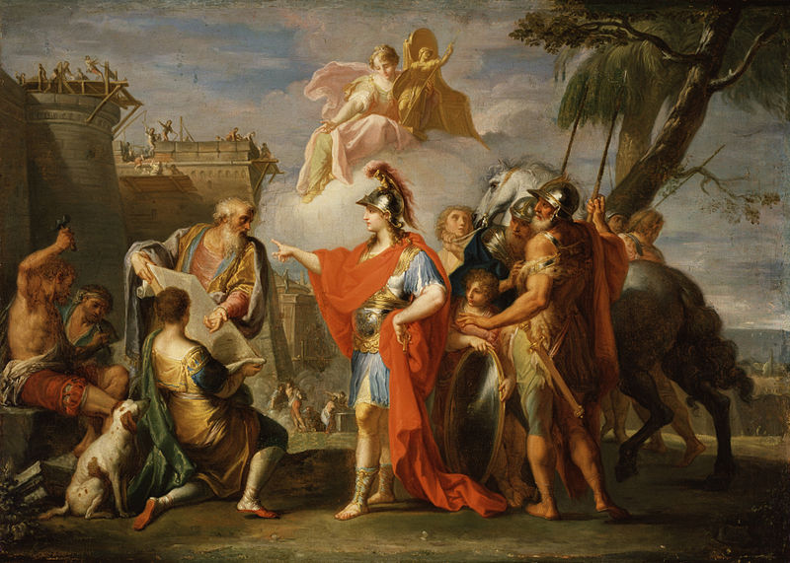He commanded the workmen to proceed, while he went to visit the temple of Ammon.  
  
This was a long and painful, and, in two respects, a dangerous journey; first, if they should lose their provision of water, as for several days none could be obtained; and, secondly, if a violent south wind should rise upon them, while they were travelling through the wide extent of deep sands, as it is said to have done when Cambyses led his army that way, blowing the sand together in heaps, and raising, as it were, the whole desert like a sea upon them, till fifty thousand were swallowed up and destroyed by it … but Alexander was not easily to be diverted from anything he was bent upon …

**Alexander the Great founding Alexandria** by Placido Constanzi, 18th Century.

In this journey, the relief and assistance the gods afforded him in his distresses were more remarkable, and obtained greater belief than the oracles he received afterwards … first, plentiful rains that fell preserved them from any fear of perishing by drought, and, allaying the extreme dryness of the sand, which now became moist and firm to travel on, cleared and purified the air. Besides this, when they were out of their way, and were wandering up and down … they were set right again by some ravens, which flew before them when on their march, and waited for them when they lingered and fell behind; and the greatest miracle, as Callisthenes tells us, was that if any of the company went astray in the night, they never ceased croaking and making a noise till by that means they had brought them into the right way again. 

Having passed through the wilderness, they came to the place where the high priest, at the first salutation, bade Alexander welcome from his father Ammon. And being asked by him whether any of his father's murderers had escaped punishment, he charged him to speak with more respect, since his was not a mortal father. Then Alexander, changing his expression, desired to know of him if any of those who murdered Philip were yet unpunished, and further concerning dominion, whether the empire of the world was reserved for him? This, the god answered, he should obtain, and that Philip's death was fully revenged, which gave him so much satisfaction that he made splendid offerings to Jupiter, and gave the priests very rich presents. This is what most authors write concerning the oracles. But Alexander, in a letter to his mother, tells her there were some secret answers, which at his return he would communicate to her only…  
  
… But what he pronounced himself upon this subject was even more like a philosopher, for he said God was the common father of us all, but more particularly of the best of us. To the barbarians he carried himself very haughtily, as if he were fully persuaded of his divine birth and parentage; but to the Grecians more moderately, and with less affectation of divinity, except it were once in writing to the Athenians about Samos, when he tells them that he should not himself have bestowed upon them that free and glorious city; "You received it," he says, "from the bounty of him who at that time was called my lord and father," meaning Philip. However, afterwards being wounded with an arrow, and feeling much pain, he turned to those about him, and told them, "This, my friends, is real flowing blood, not Ichor-"Such as immortal gods are wont to shed." And another time, when it thundered so much that everybody was afraid, and Anaxarchus, the sophist, asked him if he who was Jupiter's son could do anything like this, "Nay," said Alexander, laughing, "I have no desire to be formidable to my friends, as you would have me, who despised my table for being furnished with fish, and not with the heads of governors of provinces." …

From what I have said upon this subject, it is apparent that Alexander in himself was not foolishly affected, or had the vanity to think himself really a god, but merely used his claims to divinity as a means of maintaining among other people the sense of his superiority. Plutarch